# 14. Spring MVC

-Presentation layer is the front door into your app.

-Some major considerations when developing web applications: performance, user-friendliness, interactivity and richness, accessibility

## 14.1 Setting up the Data and Lower-Level Layers

-(See in book)

## 14.2 Introduce MVC

-MVC in pattern in implementing the presentation layer of app. Main principle of MVC: define an architecture with clear responsibilities for different components.

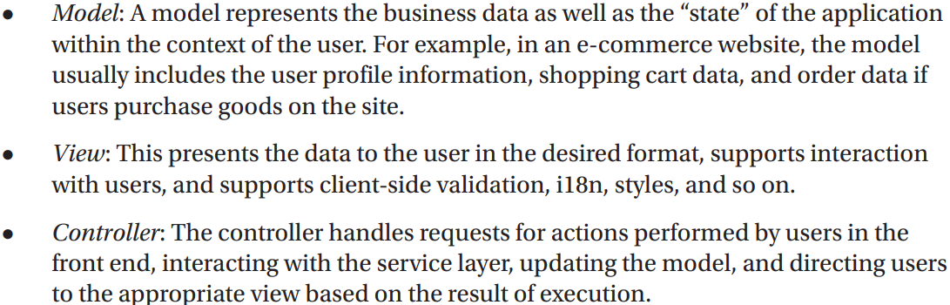

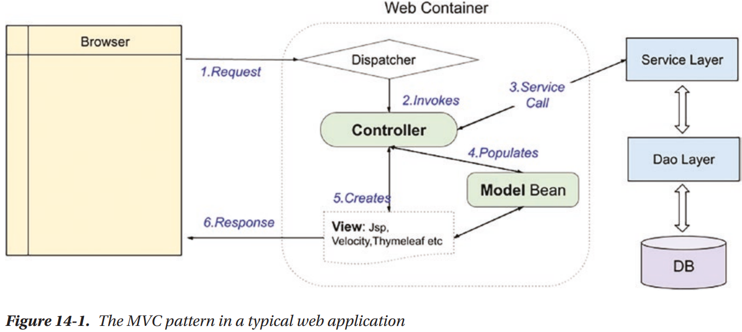

-A normal view request is handled:

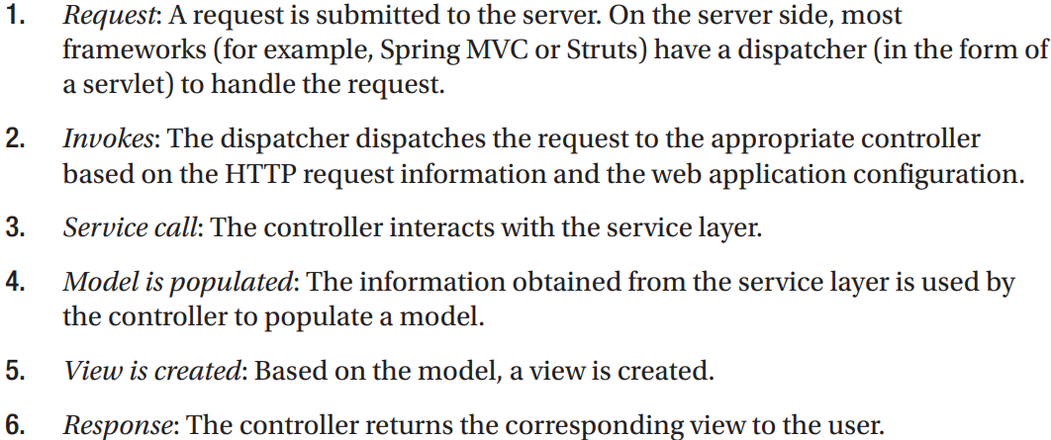

## 14.3 Introduce Spring MVC

-In Spring Framework, Spring MVC module provides support for MVC pattern with support features (theming, i18n, validation, type conversion, formatting)

### 14.3.1 Spring MVC WebApplicationContext Hierarchy

-**DispatcherServlet**: the central servlet that receives requests and dispatches them to appropriate controllers. There can be any number of DispatcherServlet instances for various purposes (UI requests, RESTful-WS requests). Each DispatcherServlet has its own WebApplicationContext configuration which defines servlet-level characteristics.

-Spring MVC maintains a root WebApplicationContext which includes application-level configurations (back-end data source, security, service, persistence layer configuration). The root WebApplication will be available to all servlet-level WebApplicationContexts

-Example: 2 DispatcherServlet instances: application servlet and RESTful servlet.

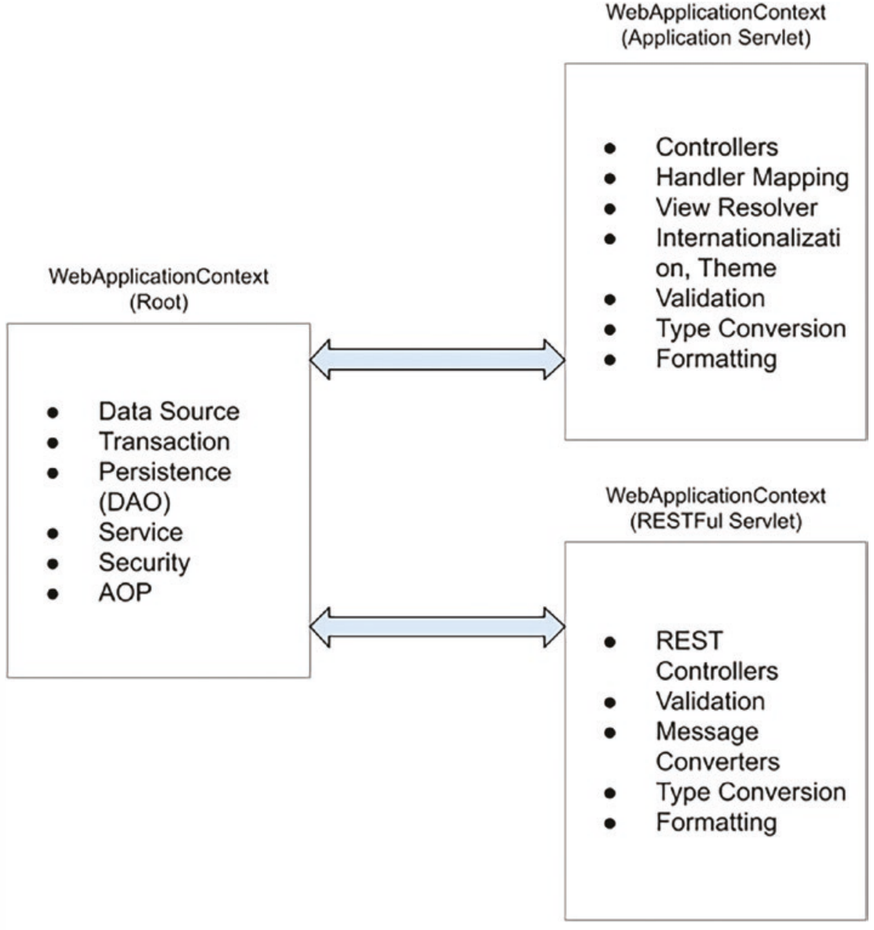

### 14.3.2 Spring MVC Request Life Cycle

-Main components involved in handling a request in Spring MVC:

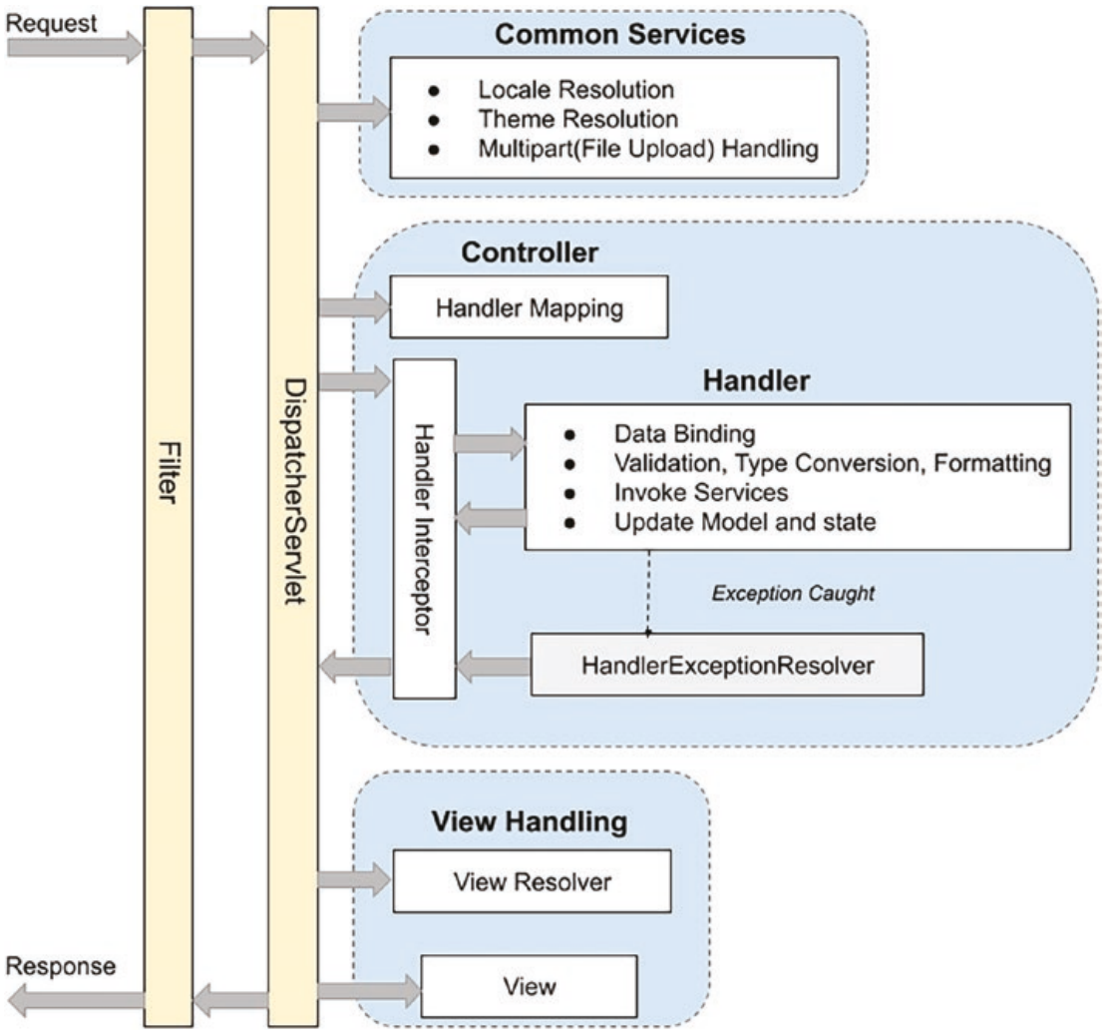

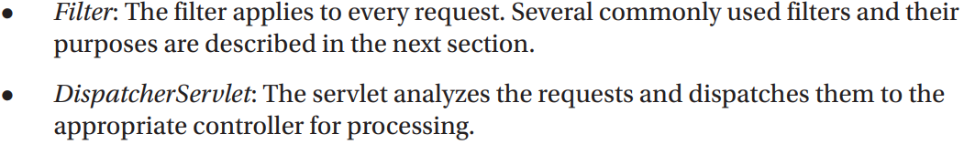

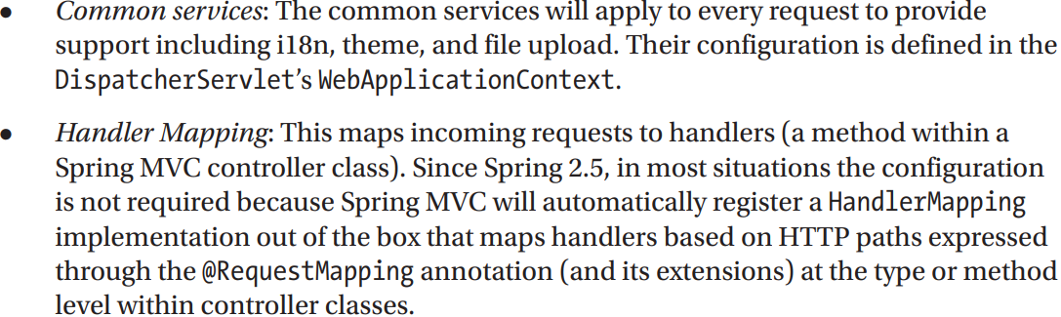

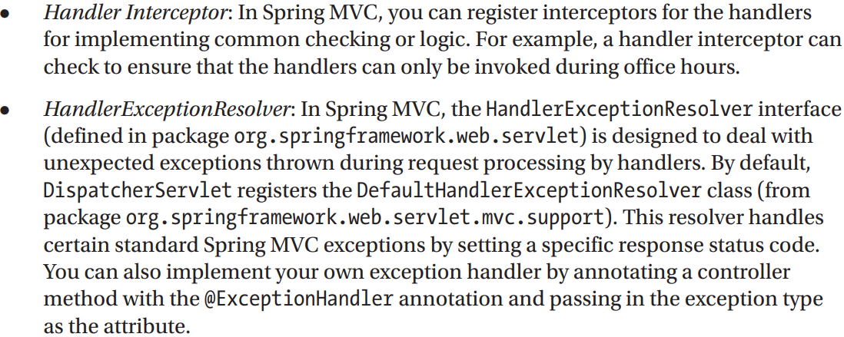

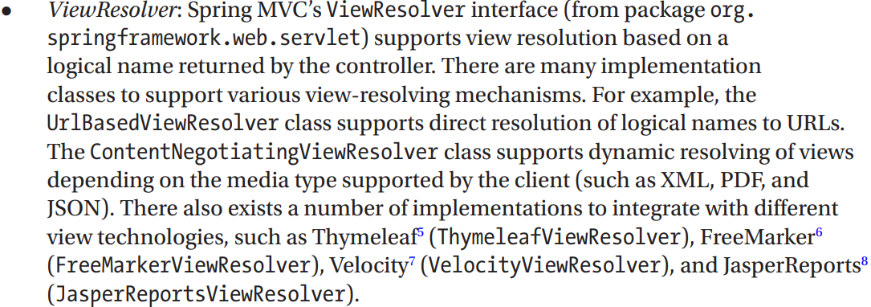

### 14.3.3 Spring MVC Configuration

-To **configure Spring MVC support** for web applications, perform configurations for web deployment descriptor:

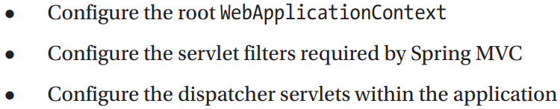

-The **easiest way** is to extend **AbstractAnnotationConfigDispatcherServletInitializer**

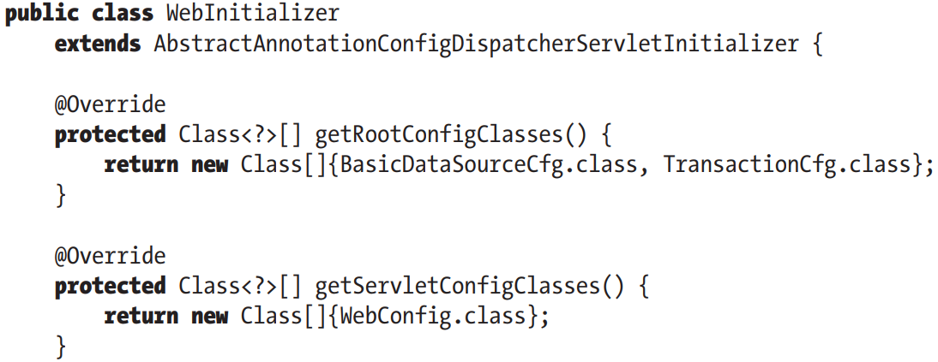

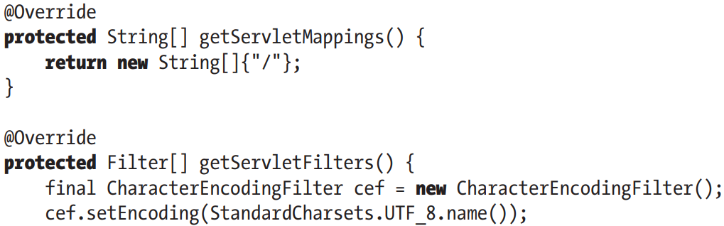

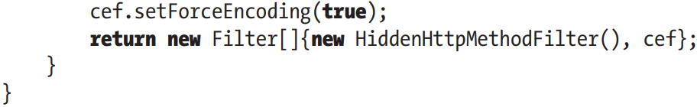

-AbstractAnnotationConfigDispatcherServletInitializer implement **WebApplicationInitializer**: in order to configure **ServletContext**.

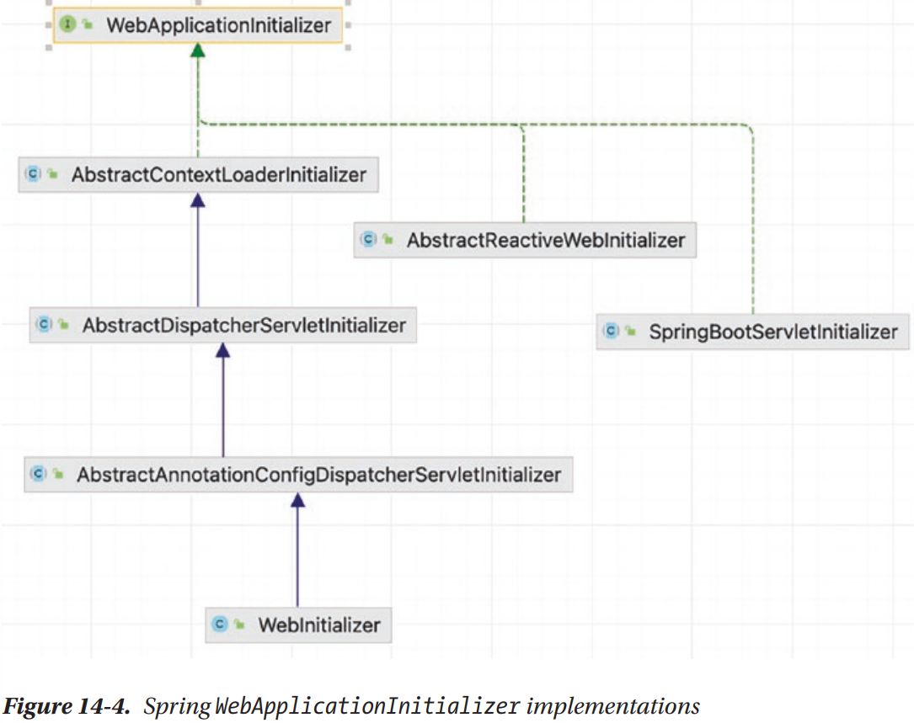

-All classes implement **WebApplicationInitializer** are automatically detected by **SpringServletContainerInitializer** (implement **ServletContainerInitializer**, which bootstrap automatically in Servlet 3.0 containers)

-Overridden methods:

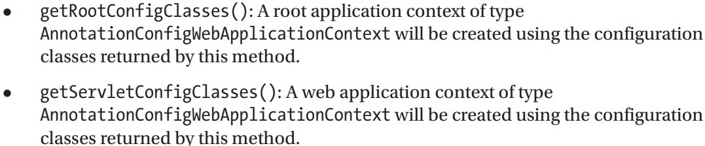

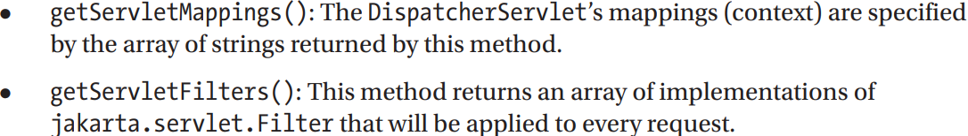

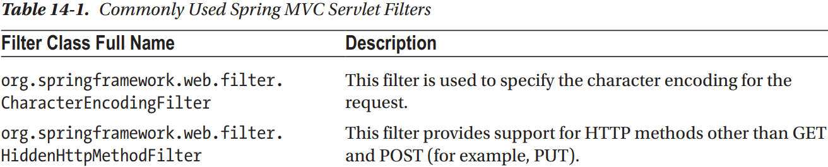

### 14.3.4 Create the 1st View in Spring MVC

-Thymeleaf: server-side Java template engine for both web and stand-alone environments, it integrates smoothly with Spring applications since it was created specially for them.

-Dependencies: Jakarta.servlet-api, spring-webmvc, thymeleaf-spring

### 14.3.5 Configure DispatcherServlet

-Configuration class that defines all infrastructure beans needed for Spring web application:

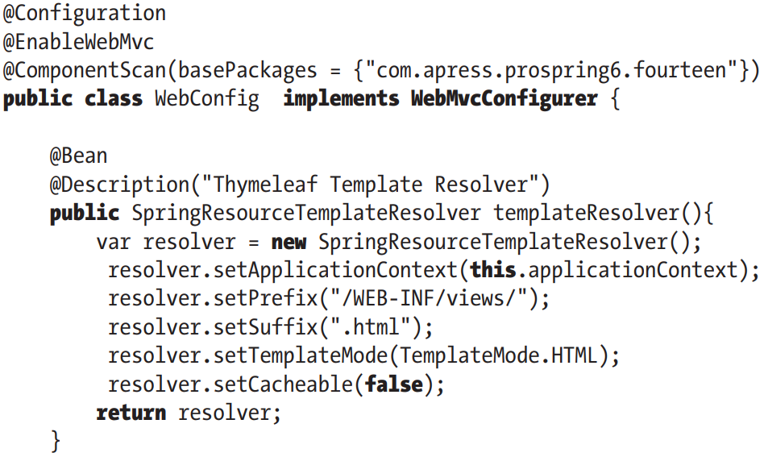

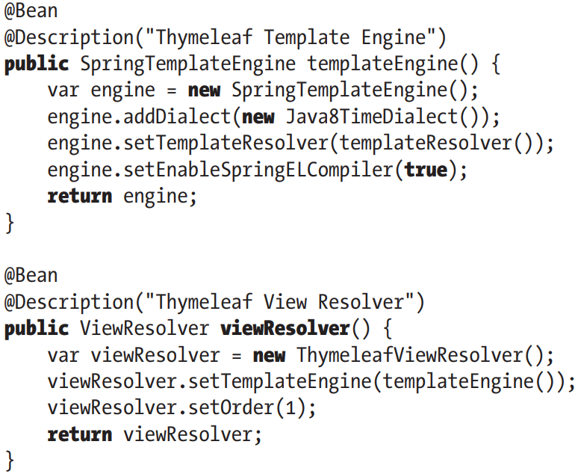

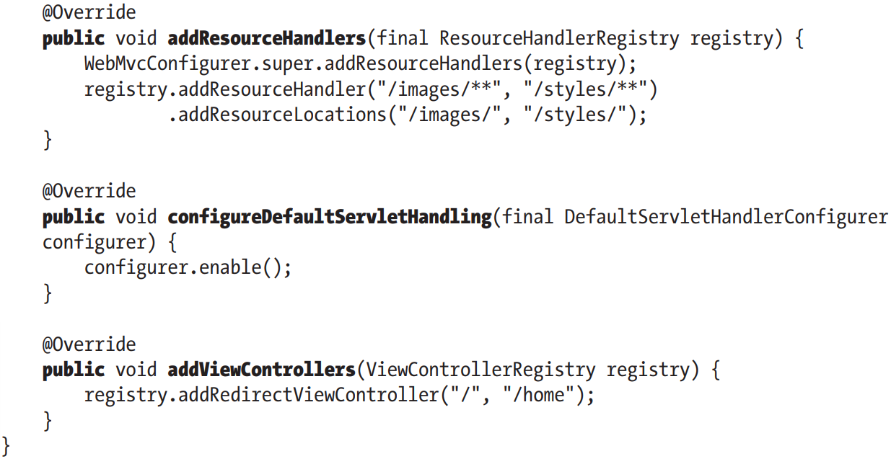

-**WebMvcConfigurer**: defines callback methods to customize configuration for Spring MVC enabled by @EnableWebMvc.

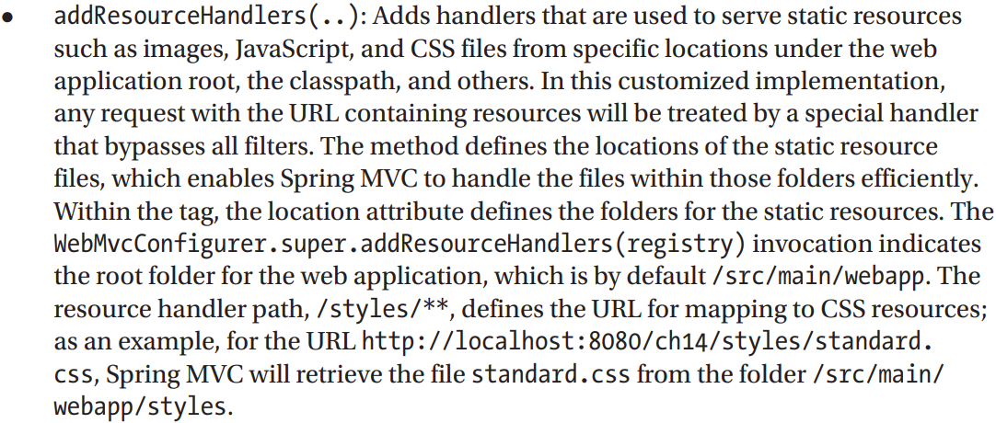

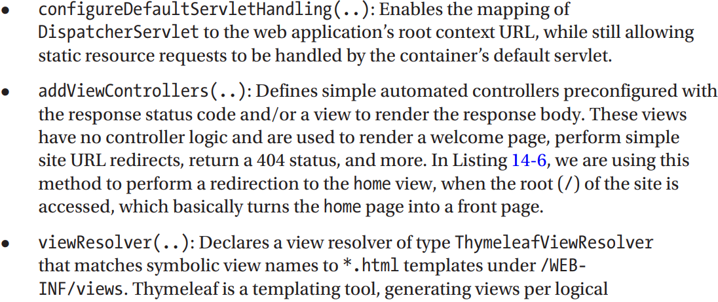

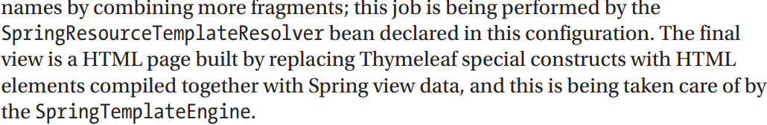

### 14.3.6 Implement Spring Controllers

-HomeController:

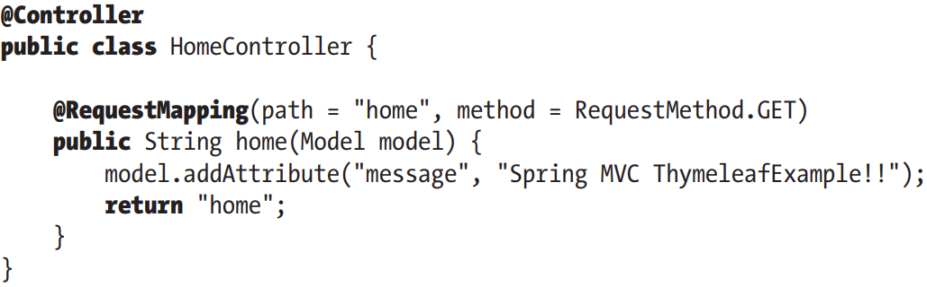

-The controller class is sometimes called a handler, the methods are handler methods.

### 14.3.7 Implement the View

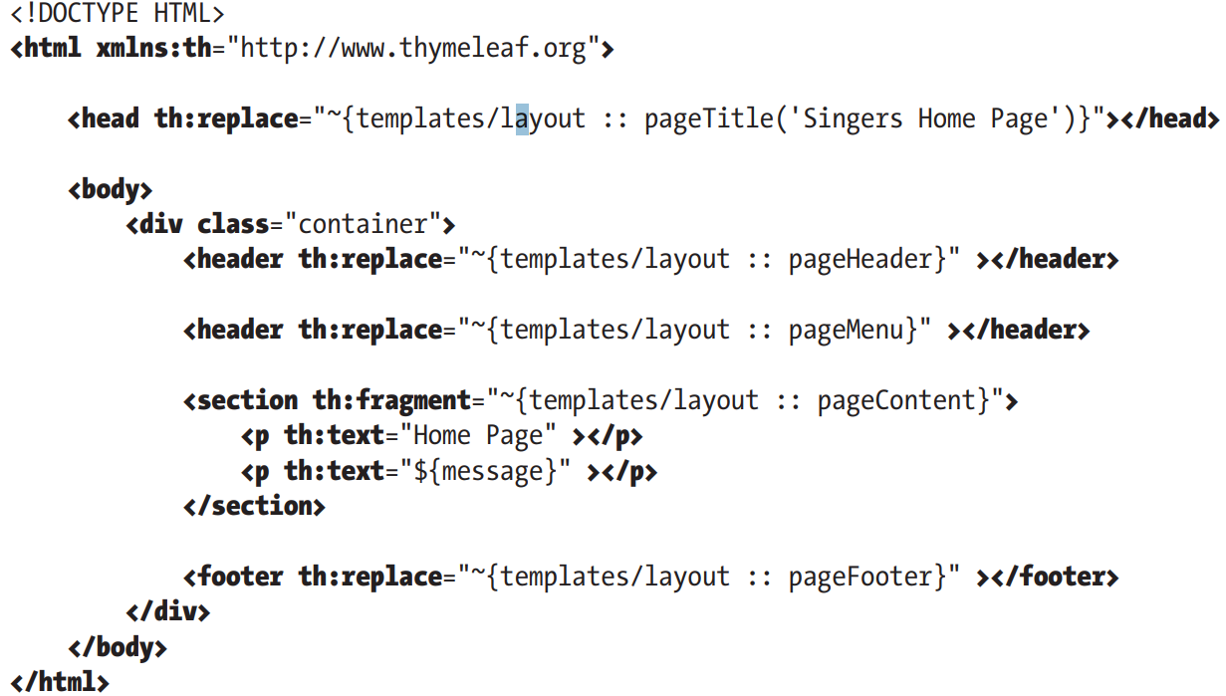

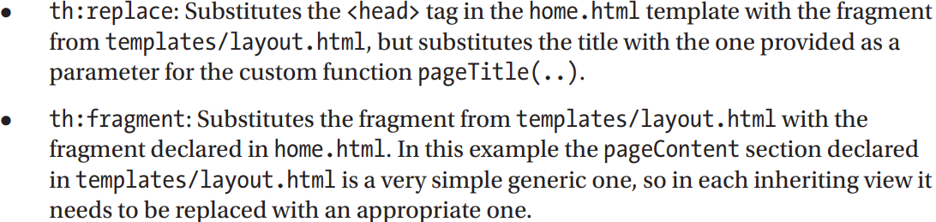

### 14.3.8 Testing the Home View

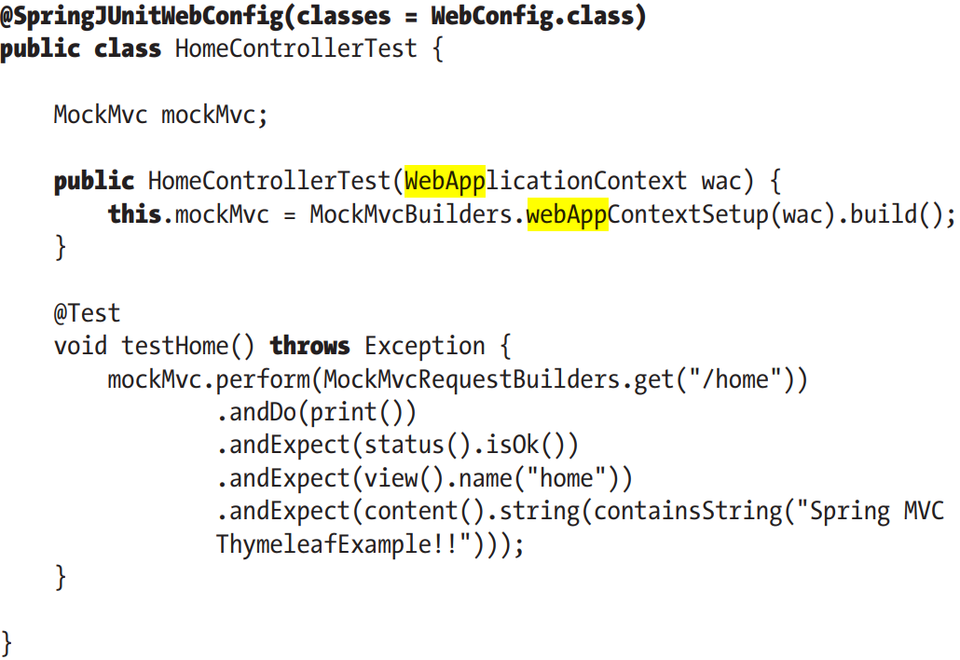

### 14.3.9 Understand the Spring MVC Project Structure

-In web application, lots of files are required to support various features. It’s good practice to store files that serve different purposes in well-structured folder hierarchy:

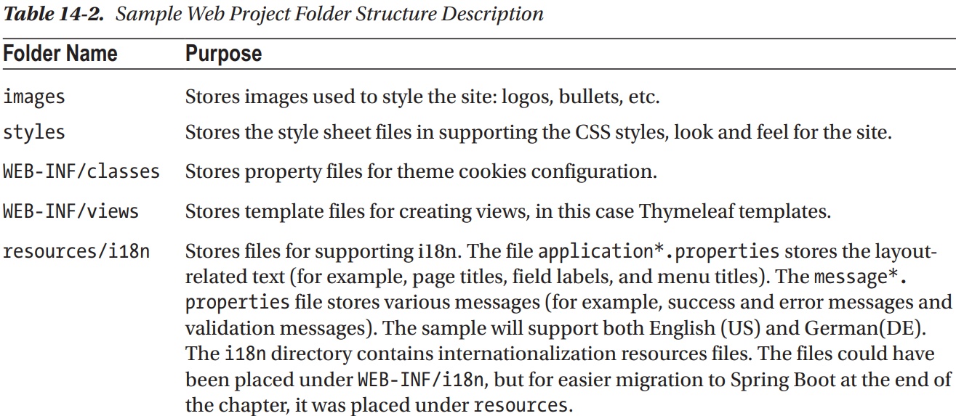

## 14.4 Enabling Internationalization (i18n)

-Enabling i18n: externalize language-related UI settings into various properties files in /resources/i18n

### 14.4.1 Configure i18n in DispatcherServlet Configuration

-Add internationalization configuration: declare MessageSource bean, inject it in template resolver, add request interceptors to replace all message codes in view templates with test representations in configured language.

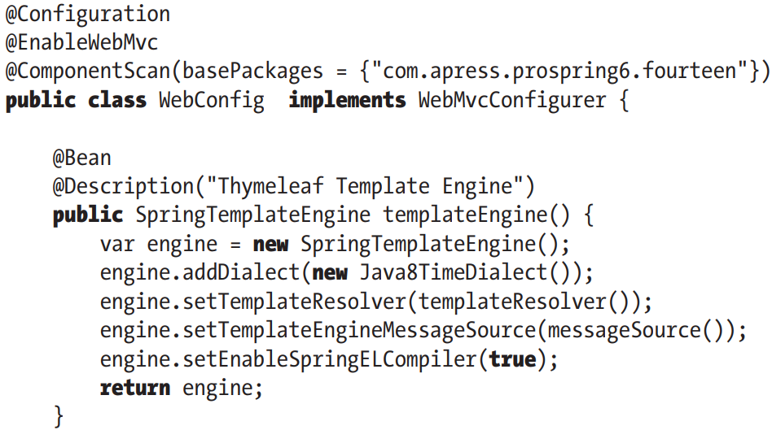

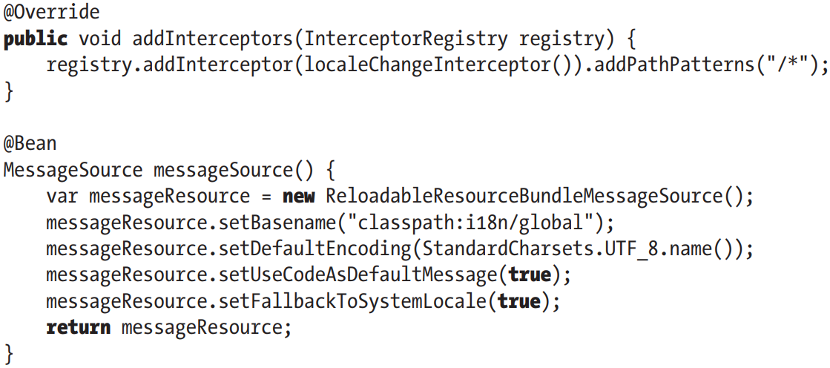

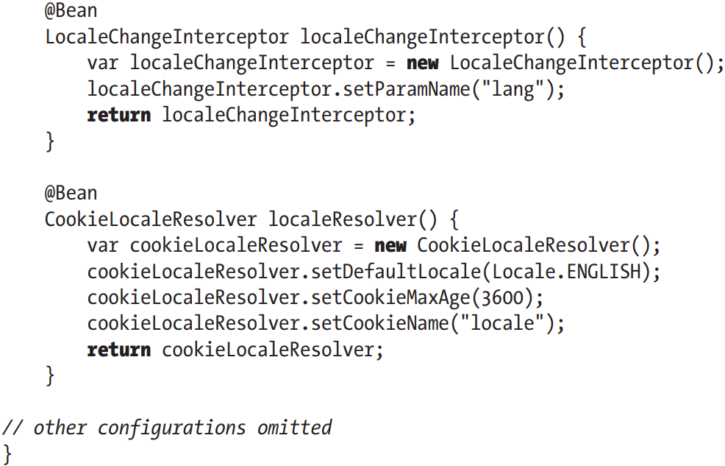

+**MessageSource** bean is declared as **ReloadableResourceBundleMessageSource** which implements MessageSource: load messages from defined files to support i18n.

+**setFallbackToSystemLocale()**: whether to fall back to local of system when a special resource bundle isn’t found.

+**LocaleChangeInterceptor**: support locale switching with a customizable request parameter.

+**CookieLocaleResolver**: support the storage and retrieval of locale settings from user browser’s cookie

### 14.4.2 Modify Views for i18n Support

-layout:

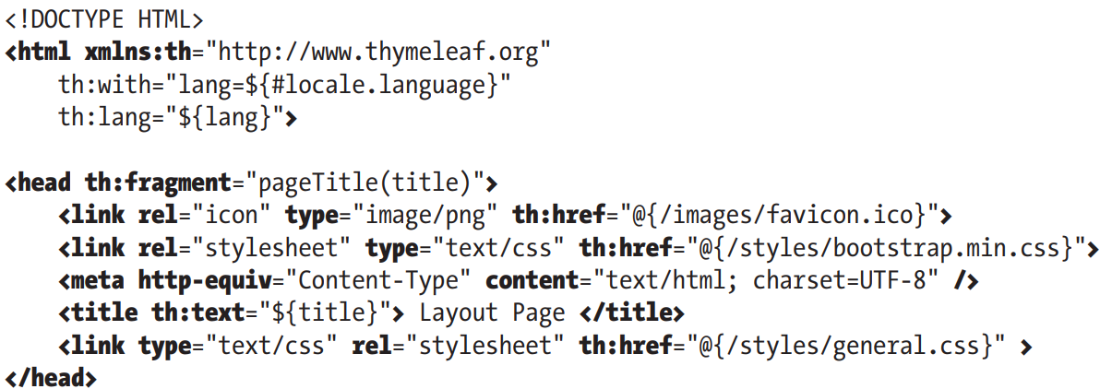

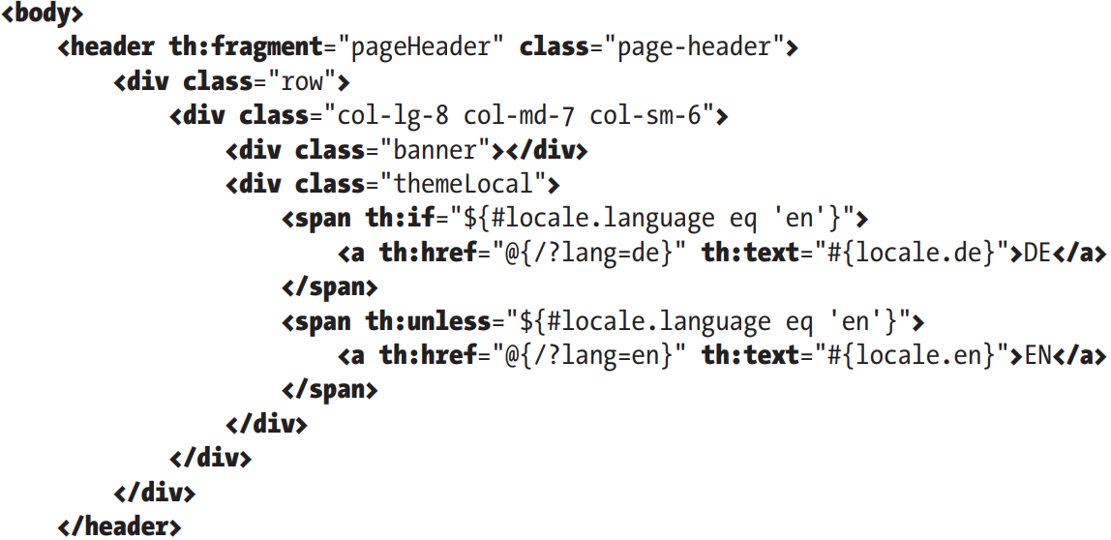

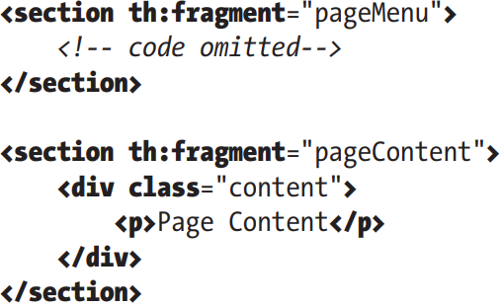

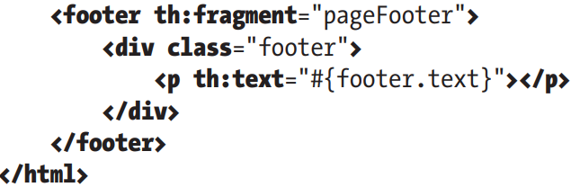

+HTML lang attribute identify then language of text contend on Web. th:lang populates this attribute with value of lang parameter.

+Spring MVC stores locale setting in browser’s cookie and by default kept for user session. You can setCookieMaxAge()

+To switch to English, change URL in browser to ?lang=en. Spring MVC falls back to use default.

+Locale-specific values accessed using keys #{key}

## 14.5 Use Theming and Templating

-Currently, the approach is to keep website separate from back end and create website using evolved JS frameworks (React…) that interacts with Spring REST Web.

-(See in book)

## 14.6 Implement more Complex Views

-The best practices is to follow RESTful-style URL for mapping views.

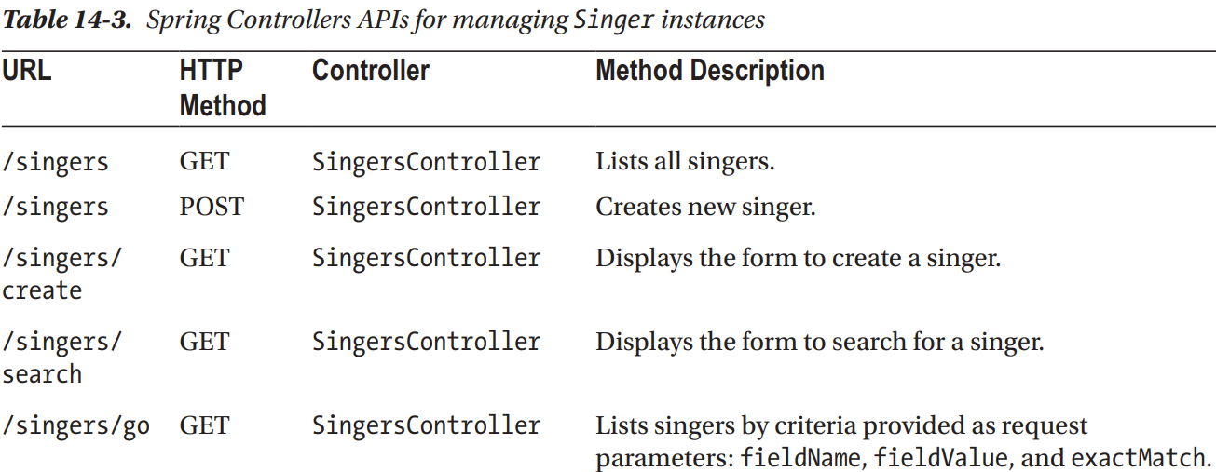

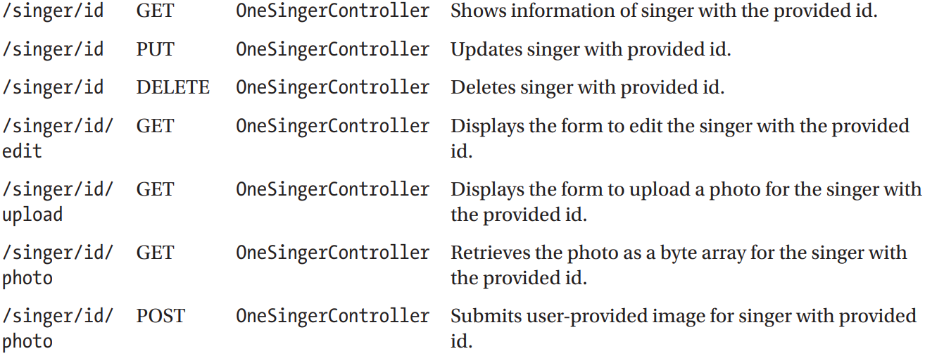

-Implement the List Singers View

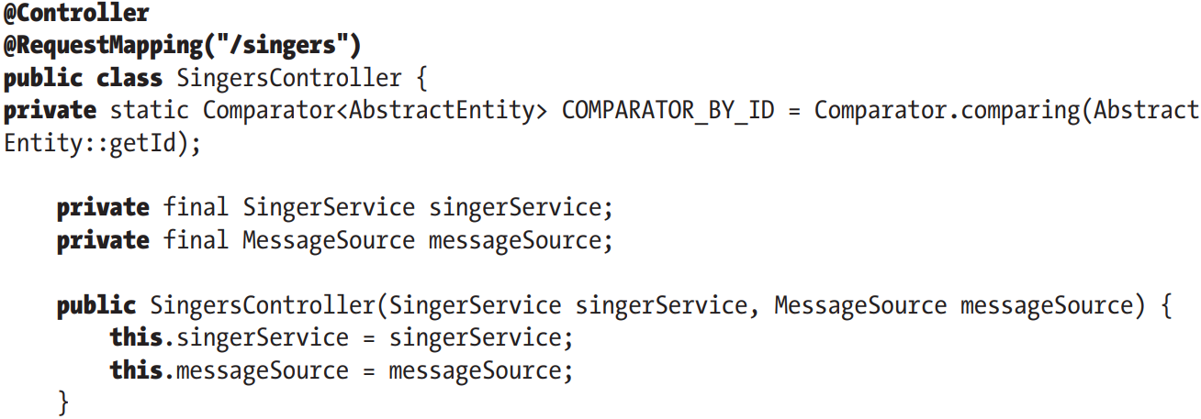

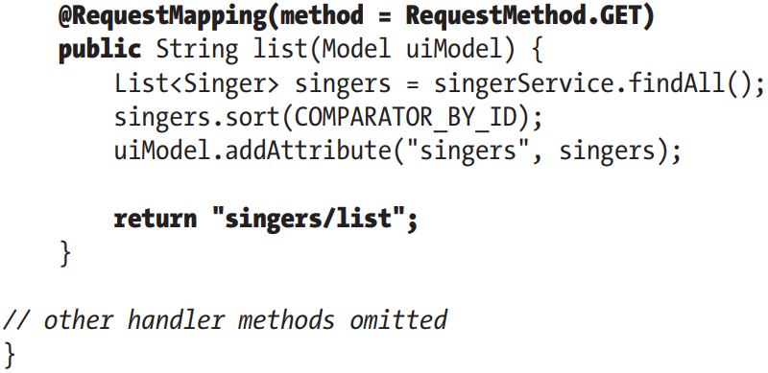

-Implement the Show Singer View

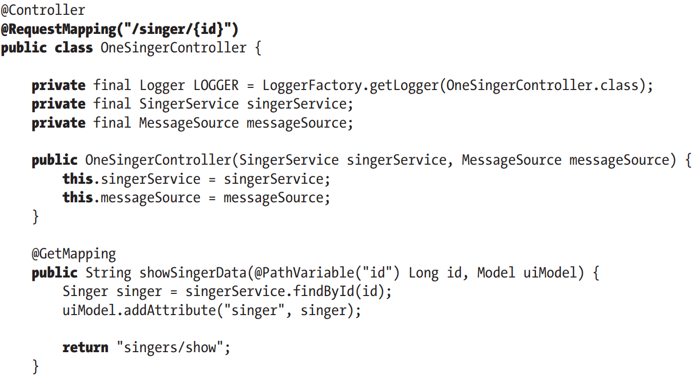

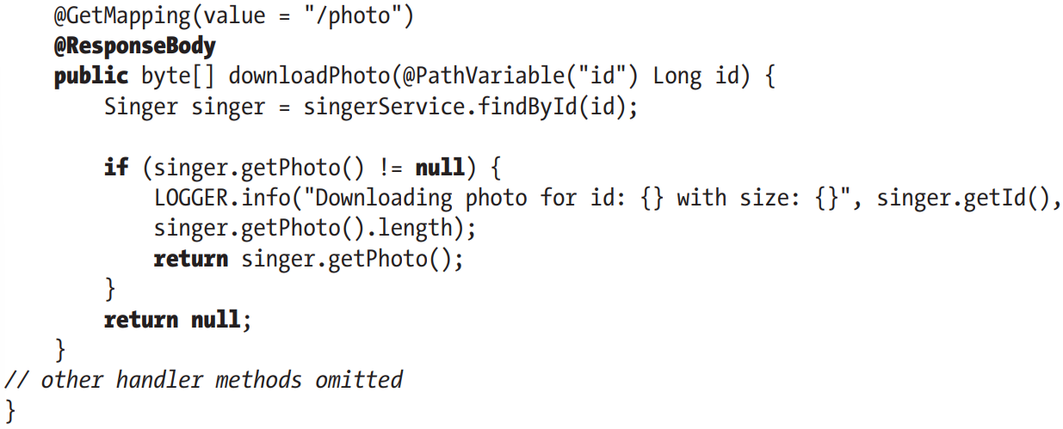

-Handle a Delete Request

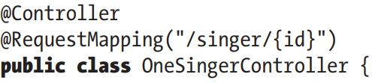

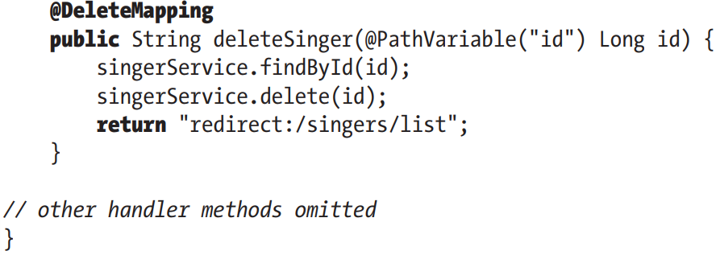

+Configuration to support PUT and DELETE methods

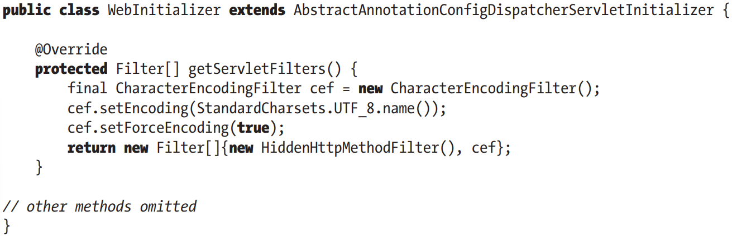

-Implement Edit Singer View

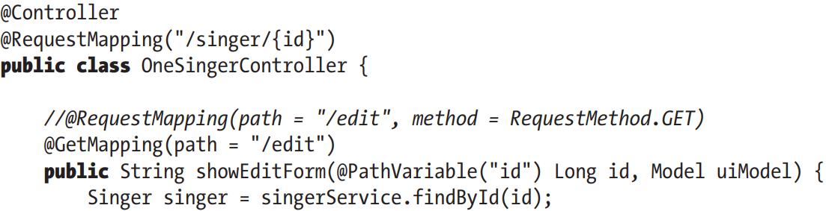

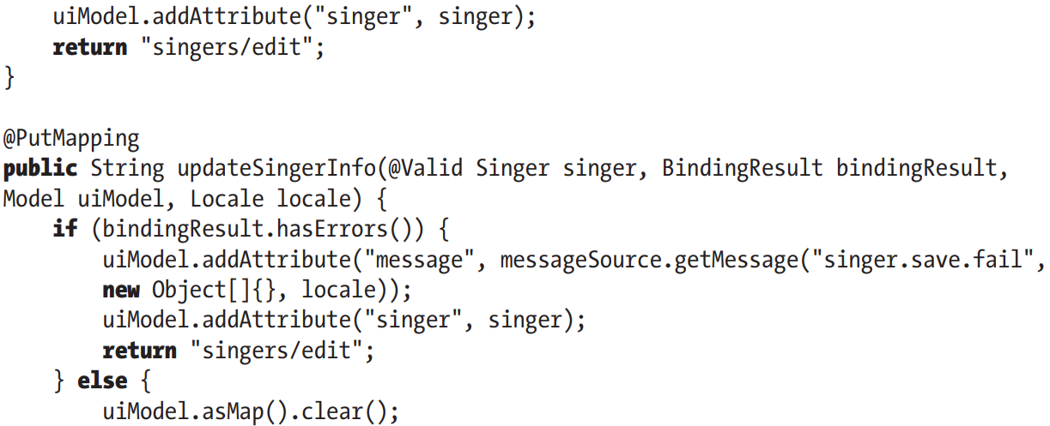

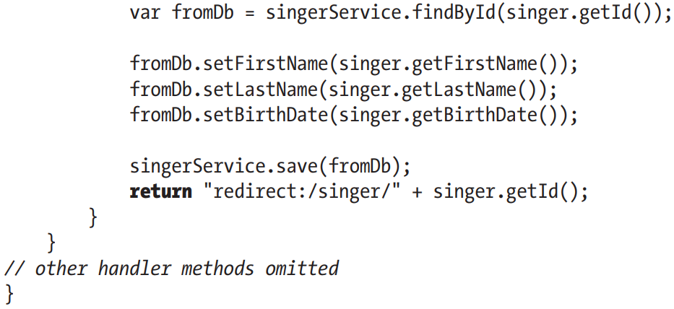

-Implement Create Singer View

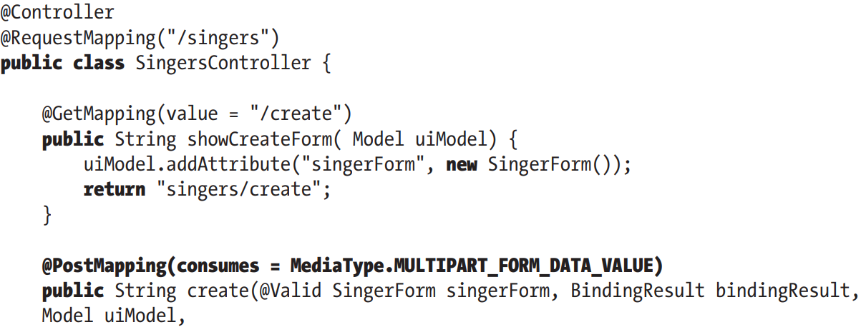

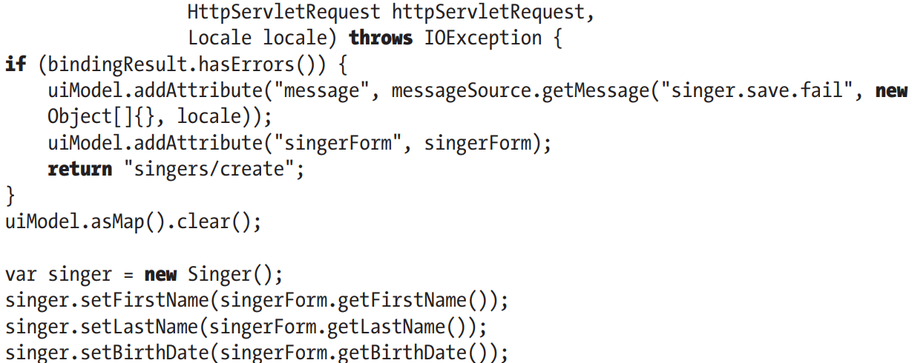

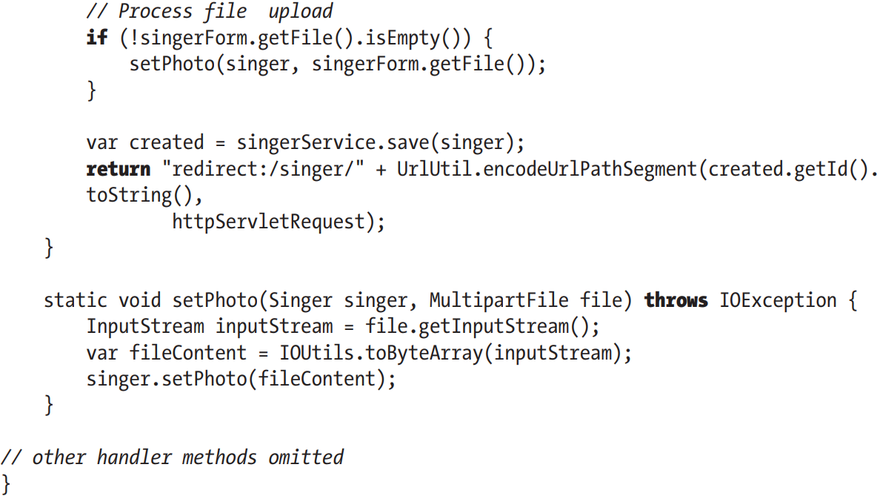

+In complex application, the entity types declared in DAO layer are never used in controllers, in web layer. Usually view types are introduced that wrap around one or more entity types and expose only useful fields, hiding details such as sensitive data (identifiers, passwords, fields that are not relevant to web context, like version field).

-SingerForm: view type that declares only fields necessary for creating Singer instance for web level



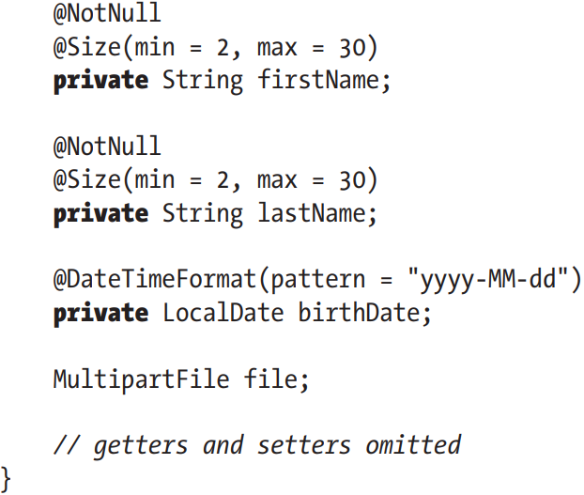

-File upload:

+Spring Bean for Support File Upload

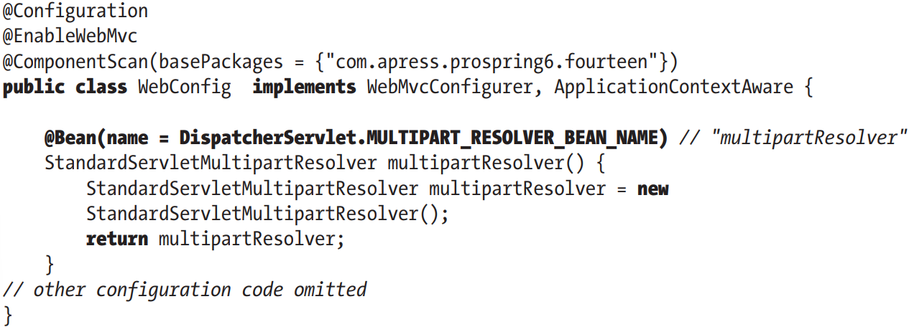

+Enable MultiParsing 3.0+ environments:

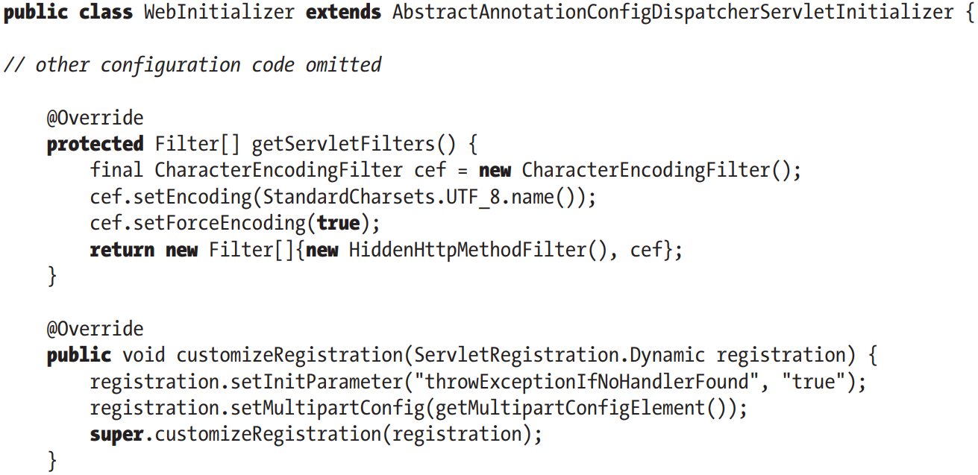

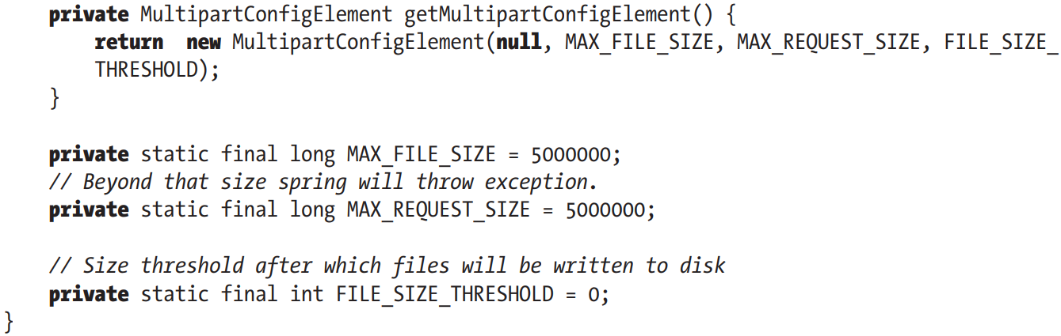

## 14.7 Enabling JSR-349 (Bean Validation)

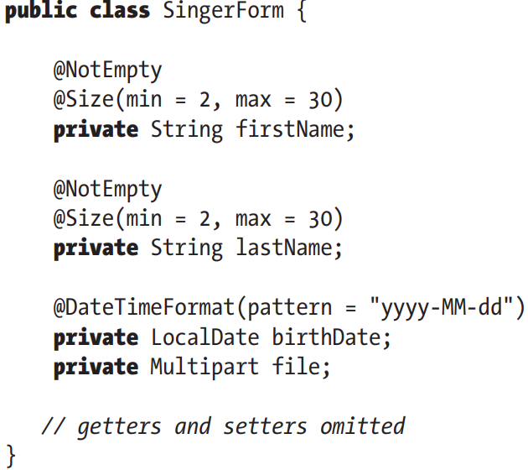

-For validation message, you specify a message key by using {}. This make it to be retrieved from ResourceBundle and hence support i18n.

+Error message codes are resolved by **MessageCodesResolver** bean registered automatically by Spring when validation is configured. The default implementation is **DefaultMessageCodesResolver**: create 2 message codes: based on name of type and based on field names.

+Example: firstName filed in class SingerForm annotated with @Size, this bean will create a group of message codes resolved in order:

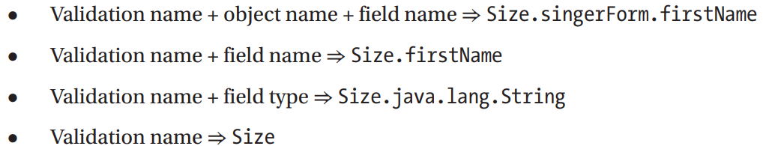

If neither of these is declared, the default message is set to annotation full name + “message”

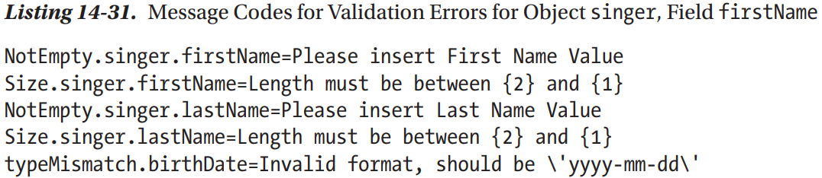

-We can use message attribute:

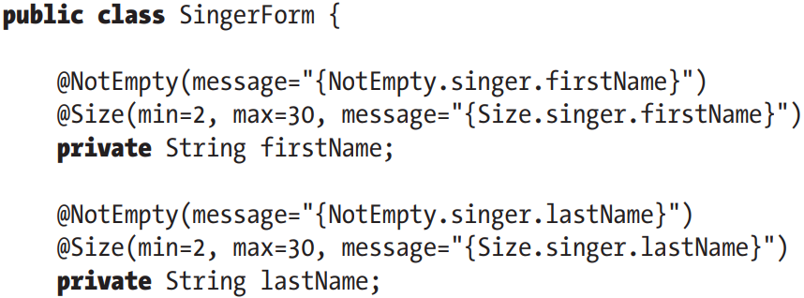

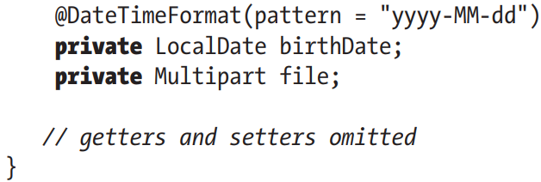

-To enable JSR-349 during web data binding process, use **@Valid**

-Make JSR-349 validation message use the same ResourceBundle instance as for the views

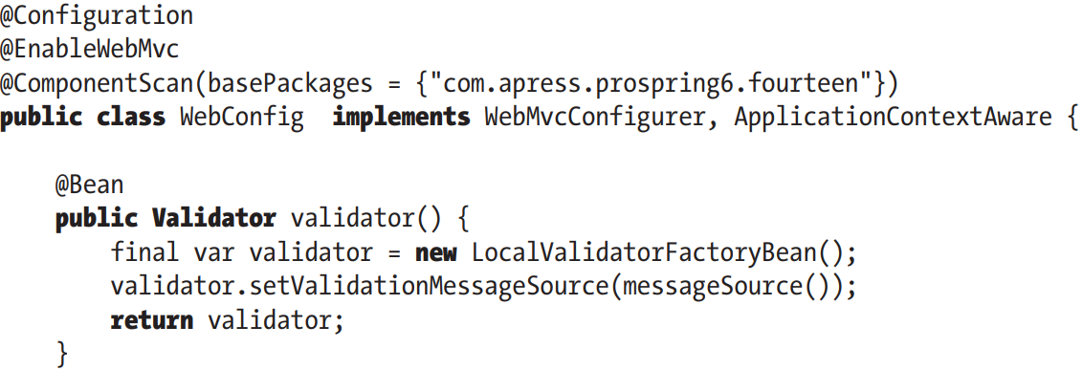

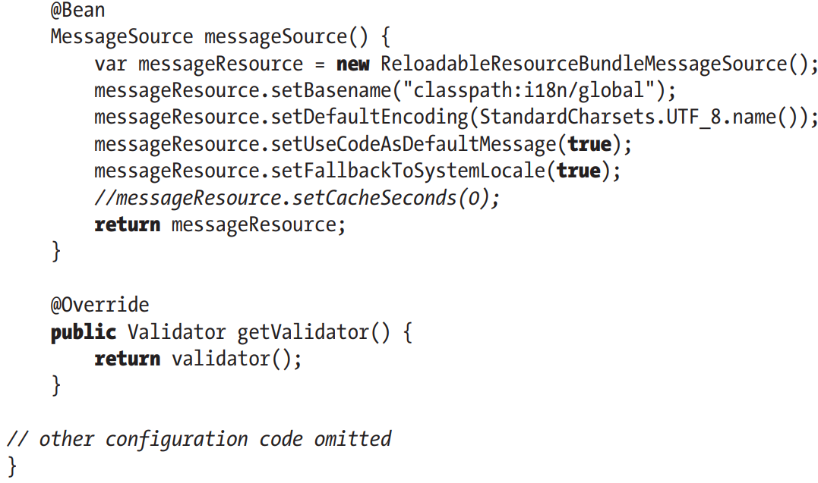

+Validator bean **LocalValidatorFactory** bean for JSR-349 support. We use **setValidationMessageSource()** to reference the MessageSource bean which instruct JSR-349 validator to look up messages by the code from MessageSource bean.

## 14.8 Exception Handling

-Spring MVC catches and handles exceptions using implementations of **HandlerExceptionResolver**.

-The typical way to treat MVC exception is to prepare a model and select an error view. Multiple exception resolvers can be used and ordered in a chain to treat different type of exceptions.

-Spring MVC supports **default resolvers**, declared in DispatcherServlet.properties file in spring-webmvc

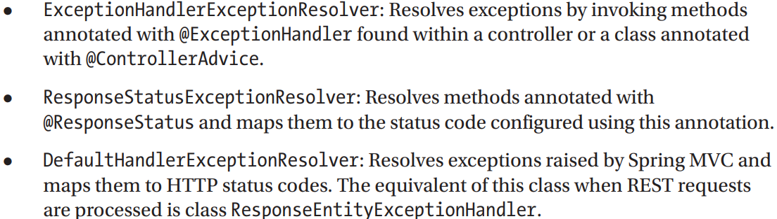

-SimpleMappingExceptionResolver: beans of this type can configured to map exception classes to view names->render error pages in browser application

-Exception resolver provides information: handler method + arguments.

-Instead of Apache Tomcat page, we can display a customized error view. Spring MVC offers no default (fallback) error page when a view or a handle method is not found. It just forwards showing message to server. To override this behavior:

+Customize DispatcherServlet to throw NoHanlderFoundException when handler method can’t be found: customizeRegistration()

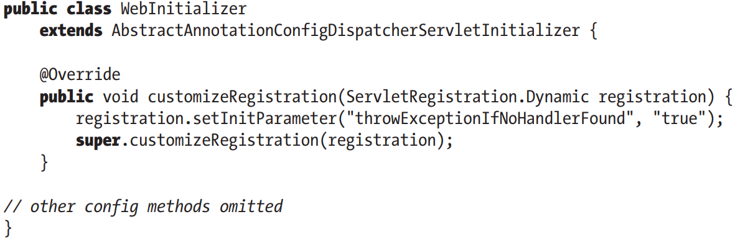

+**Remove** DefaultServletHttpRequest (always forwarded to it):

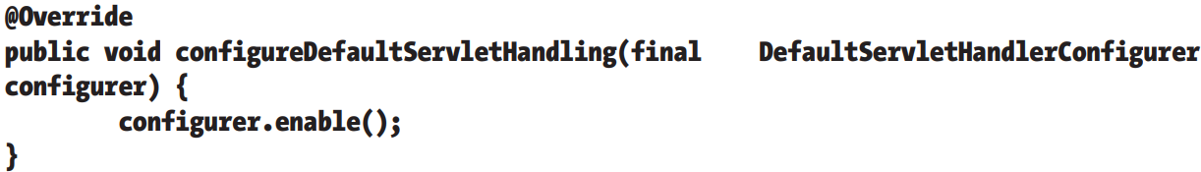

+2nd: HanderExceptionResolver implementation:

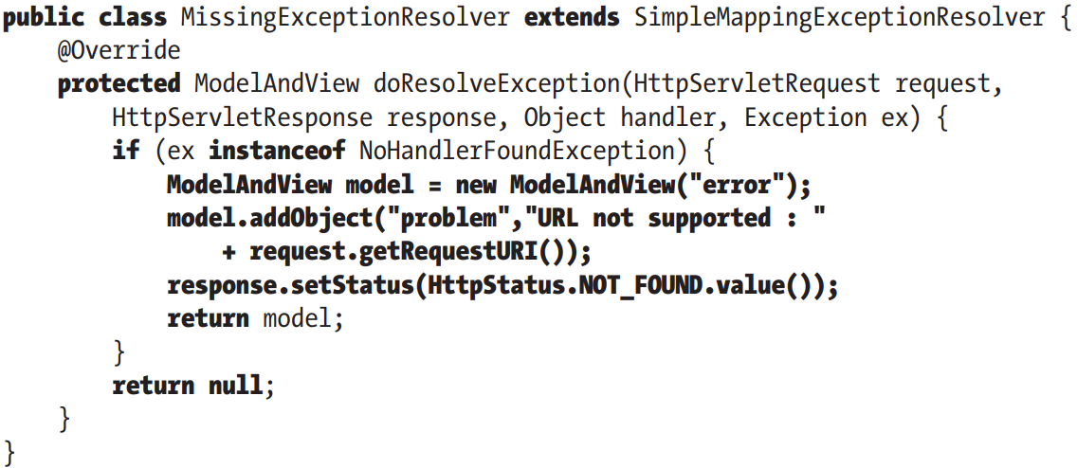

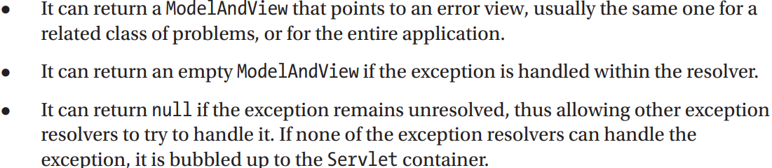

-3rd step: declare bean of this type with lowest priority (highest precedence), so that when sth goes wrong, this exception resolver will be used first

**+@ControllerAdvice**: declare different error handle methods and group all of them. This bean intercepts exceptions thrown by handler methods and maps them to @ExceptionHandler methods to process them and render error views.

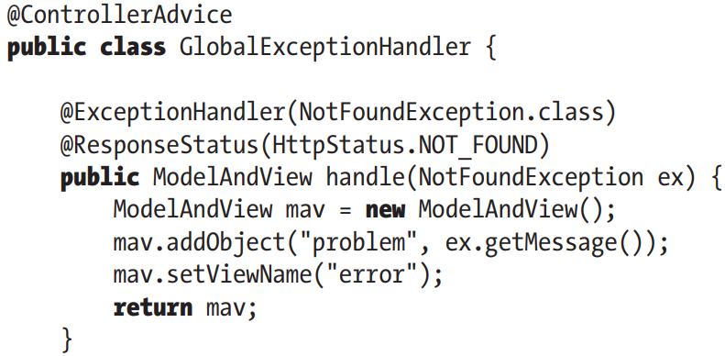

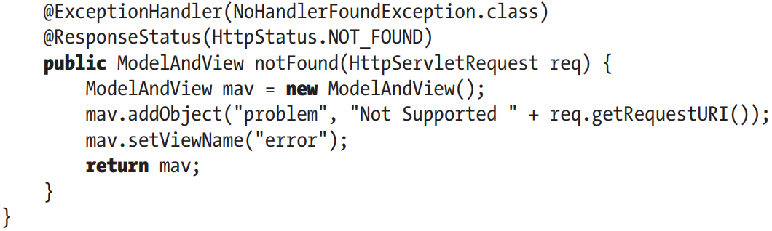

## 14.9 Switch to Spring Boot

# 15. Spring REST Support

## 15.1 Introduce RESTful Web Services

### 15.1.1 Use Spring MVC to Expose RESTful Web Services

### 15.1.2 Implement SingerController

### 15.1.3 Test the RESTful-WS Application

### 15.1.4 REST Exception Handling Using ResponeEntity<t>

### 15.1.5 REST Exception Handling use @RestControllerAdvice

## 15.2 RESTful-WS with Spring Boot

# 16 Spring Native and Other Goodies

## 16.1 Spring Native Images

### 16.1.1 The Application

### 16.1.2 The Configuration

## 16.2 Spring for GraphQL

## 16.3 Spring Kotlin Applications

### 16.3.1 The Configuration

### 16.3.2 The Code

# 17. Securing Spring Web Applications

## 17.1 Configure Spring Security: The Classic Way

### 17.1.1 JDBC Authentication

### 17.1.2 Testing Secured Web Applications

## 17.2 Configure Spring Security: The Spring Boot way

# 18. Monitoring Spring Applications

## 18.1 JMX Support in Spring

### 18.1.1 Exporting a Spring Bean to JMX

### 18.1.2 Using VisualVM for JMX Monitoring

### 18.1.3 Monitoring Hibernate Statistics

## 18.2 JMX with Spring Boot

## 18.3 Monitoring Applications with Spring Boot Actuator

### 18.3.1 Spring Boot Actuator Endpoints

### 18.3.2 Use Spring Boot Actuator with Micrometer

# 19. Spring WebSocket Support

## 19.1 Introduce WebSocket

## 19.2 Use WebSocket with Spring

## 19.3 Use WebSocket API

## 19.4 Use SockJS

## 19.5 Send Messages with STOMP

### 19.5.1 Spring Boot Equivalent Application